**Blood relationships**

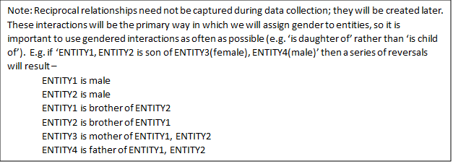

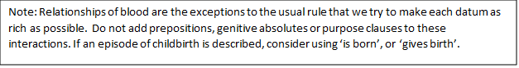

**ENTITY is father/mother/child/son/daughter/sister/brother/twin of ENTITY** (note: to capture older/younger siblings, add 'is older than' datum)

**ENTITY is grandfather/grandmother/grandson/granddaughter/uncle/aunt of ENTITY** (note: use only if it is impossible to determine (by implying external data) the closer relationships of parent, child, sibling listed above. Relationships of grandparents and aunt/uncles are difficult to code accurately so might not be able to be included in visualisations.)

**ENTITY is divine father of ENTITY** (note: use in circumstances where the divine father – mortal stepfather paradigm might be operating.)

**ENTITY1 is mother by parthenogenesis of ENTITY2** (use in instances where father is non-existent, rather than (e.g.) unknown.)

Reversal: NONE is father of ENTITY2; Otherwise treat as ‘is mother’ or ‘gives birth’

**ENTITY is a descendant of ENTITY** (note: only use where the exact relationship between two agents is not apparent and cannot be determined (by implying external data). These relationships are difficult to code accurately so might not be able to be included in visualisations. For descendants in historical period, use 'is claimed as ancestor'.)

**ENTITY is claimed as ancestor** (note: use only where the claim is made in historical world; use passive form without 'by', i.e. do not record the (historical) person claiming the lineage.)

**Relationships by marriage**

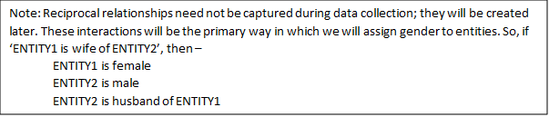

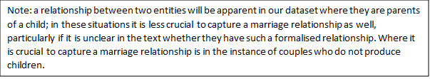

**ENTITY1 is wife/husband of ENTITY2** (Note: This is one of the exceptions to the usual rule that we try to make each datum as rich as possible.  Do not add prepositions, genitive absolutes or purpose clauses to these interactions If a more detailed episode is described, use ‘marries’ or ‘gives in marriage’ etc).

**ENTITY1 marries ENTITY2** (note: use only if marriage episode is explicitly described, otherwise use 'is wife/husband of')

Reversals: ENTITY1 is wife/husband of ENTITY2

**ENTITY1 gives in marriage ENTITY2** [indirect objENTITY3] (note: use only where ENTITY1 is not father of ENTITY2; where a father is described as giving away a daughter, use ‘marries’ or ‘is wife / husband of’ since this is conventional practice.)

Reversals: ENTITY2 is wife of ENTITY3

**Birth**

C:\Users\Greta Hawes\AppData\Local\Microsoft\Windows\INetCache\Content.MSO\EE10E461.tmp

**ENTITY1 is born**[in/on/at ENTITY2] [from ENTITY3](note: use where there is something biologically unconventional about the birth or in cases where parentage is unknown but it is necessary to still capture the event or tie to a particular place. The prepositional phrase ‘from…’ should be followed by something which does not typically give birth (e.g. ‘the Head of Medusa’, ‘Zeus’, ‘the Genitals of Ouranos’). Where the birth is biologically conventional, use ‘gives birth’.)

Reversals: ENTITY3 produces ENTITY2

but not: ENTITY2 is child of ENTITY3 (use ‘is son of’ etc to clarify parentage if needed.)

**ENTITY1 gives birth**[indir.obj.ENTITY2] [in/on/at ENTITY3]

Reversals: ENTITY1 is mother of ENTITY2 (always also use a genealogical tie to clarify full parentage if father is known.)

ENTITY2 is born at ENTITY3

**ENTITY1 is born by autochthony** [in/on/at ENTITY2]

Reversals: ENTITY2 produces autochthon ENTITY1

ENTITY1 is child of NONE, NONE